Compilación de datos sobre conexiones USB

V 1.0 – Febrero de 2018 – Alfonso Méndez

**Velocidades de los diferentes tipos de Bus**

|  |  |  |  |  |  |
| --- | --- | --- | --- | --- | --- |
|  | | |  |  |  |
|  |  |  |  |  |  |
| ***Dispositivos externos*** |  | ***PCI Express*** |  | ***Almacenamiento interno*** | |
| Firewire 400 | 400 Mb/s | PCI Express 1.x (x1) | 250 MB/s | ATA (UDMA 5) | 100 MB/s |
| Firewire 800 | 800 Mb/s | PCI Express 2.0 (x1) | 500 MB/s | PATA (UDMA 6) | 133 MB/s |
| Firewire s1600 | 1,6 Gb/s | PCI Express 3.0 (x1) | 1 GB/s | SATA I | 1,5 Gb/s |
| Firewire s 3200 | 3,2 Gb/s | PCI Express 1.x (x8) | 2 GB/s | SATA II | 3 Gb/s |
| USB 1.0 | 1,6 Mb/s | PCI Express 2.0 (x8) | 4 GB/s | SATA III | 6 Gb/s |
| USB 1.1 | 12 Mb/s | PCI Express 3.0 (x8) | 8 GB/s |  |  |
| USB 2.0 | 480 Mb/s | PCI Express 1.x (x16) | 4 GB/s |  |  |
| e-SATA | 2,4 Gb/s | PCI Express 2.0 (x16) | 8 GB/s |  |  |
| USB 3.0 | 4,8 Gb/s | PCI Express 3.0 (x16) | 16 GB/s |  |  |
| USB 3.1 o C | 10 Gb/s |  |  |  |  |
| Thunderbolt | 10 Gb/s |  |  |  |  |
| Thunderbolt 2 | 20 Gb/s |  |  |  |  |
| Thunderbolt 3 | 40 Gb/s |  |  |  |  |

**Características cables USB**

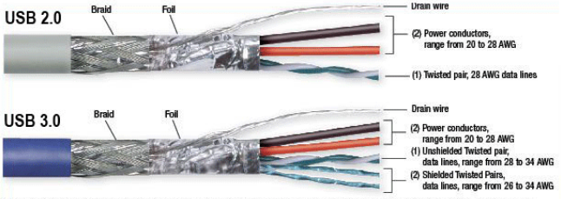

### Formas de los conectores

### USB 1.1 – 2.0 USB 3.0 USB 3.1 (C)

### https://upload.wikimedia.org/wikipedia/commons/5/58/USB-Type-C.png

### eSATA Thunderbolt 2 Thunderbolt 3

### 

### Nomenclatura conectores

### Jack / plug / male Receptacle / Port / Female

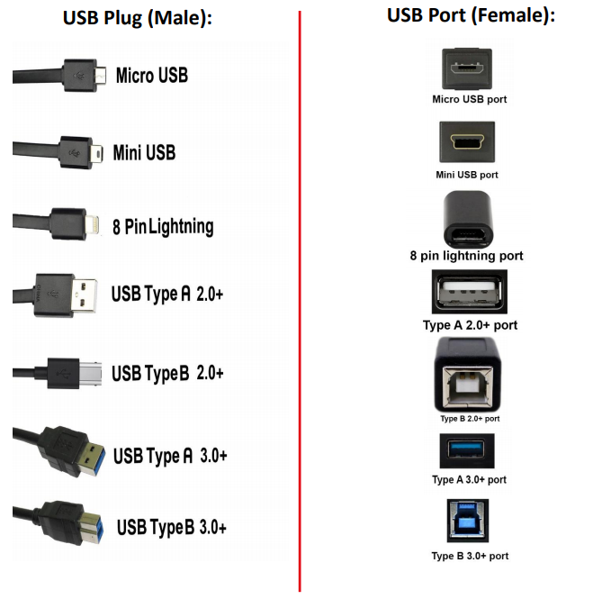

### Características eléctricas

|  |  |  |  |  |  |  |  |  |
| --- | --- | --- | --- | --- | --- | --- | --- | --- |
|  | ***Tecnología*** | ***Fabricante*** | ***Versión*** | ***Tensión de salida*** | ***Corriente máxima de salida*** | ***Potencia máxima de salida*** | ***Longitud máxima conexión*** | ***Velocidad máxima de transmisión*** |
|  | USB |  | 1.1 |  |  |  | 5 m | 12 Mbps |
|  | USB |  | 2.0 | 5 V | 500 mA | 2,5 W | 5 m | 480 Mps |
|  | USB |  | 3.0 |  | 900 mA | 4,5 W | 5 m | 4,8 Gbps |
|  | USB |  | 3.1 | 5 V - 20 V | 900 mA - 5A | 100 W | 1 m | 10 Gbps |
|  | Quick Charge | Qualcomm | 1.0 | 5 V | 2 A | 10 W |  |  |
|  |  |  | 2.0 | 5 V, 9 V y 12 V | 2 A, 2 A y 1,67 A | 18 W |  |  |
|  |  |  | 3.0 | 3,6 V - 6,5 V | 3 A | 19,5 W |  |  |
|  |  |  |  | 6,5 v - 9 V | 2 A | 18 W |  |  |
|  |  |  |  | 9 V - 12 V | 1,5 A | 18 W |  |  |
|  |  |  | 4.0 |  |  | 28 W |  |  |
|  |  |  | 4.0+ |  |  |  |  |  |
| ***Tecnologías adaptativas de carga tanto en corriente como en tensión*** | AiPower | Aukey |  | adapt. | 2,4 A |  |  |  |
|  | iSmart+ | RAVPower | 2.0 | adapt. |  |  |  |  |
|  | PowerIQ | Anker | 2.0 | adapt. |  | 18 W |  |  |

### Patillaje

### USB 2.0

**Mini B plug Mini B receptacle**

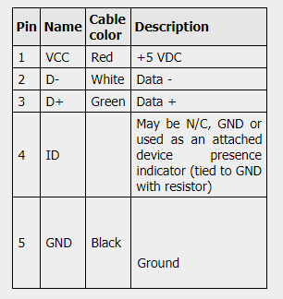

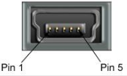

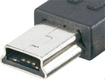

**Micro USB A plug Micro USB A receptacle**

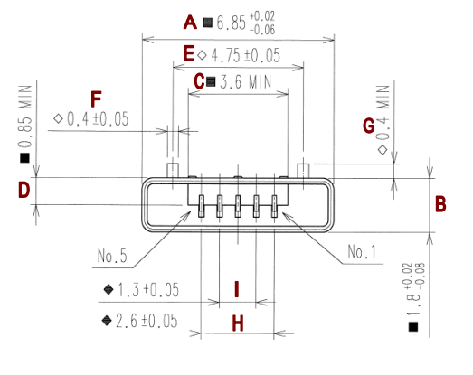

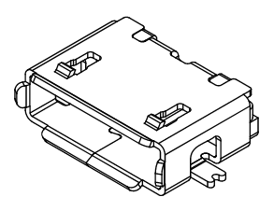

**Micro USB B plug Micro USB B receptacle**

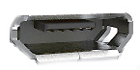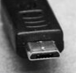

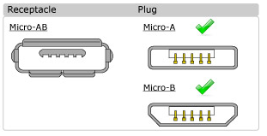

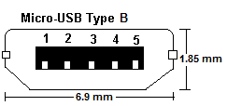

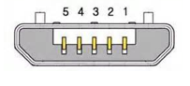

**A plug**

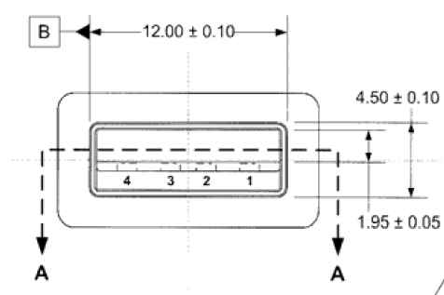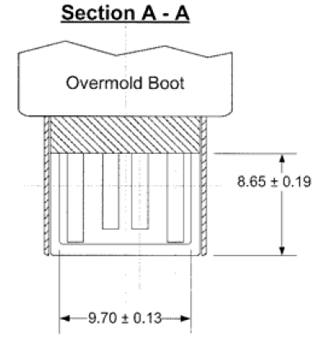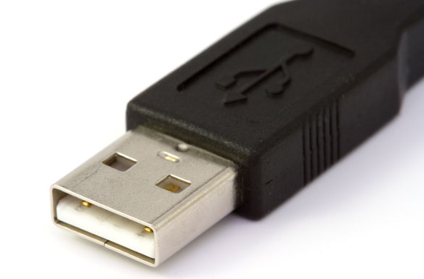

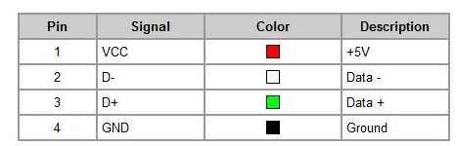

**A receptacle**

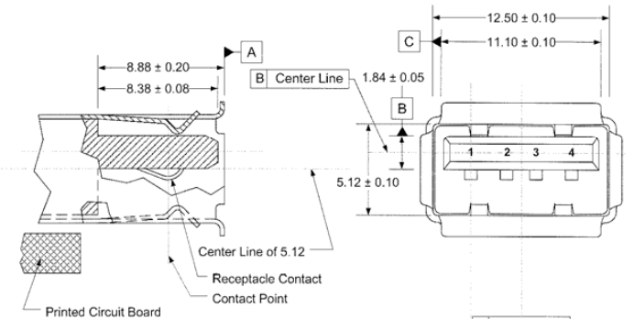

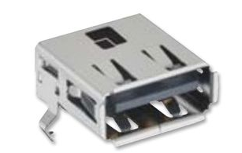

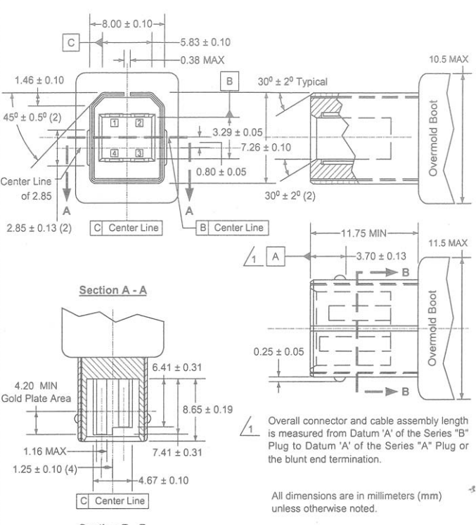**B plug**

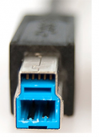

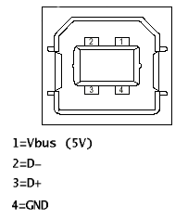

**B receptacle**

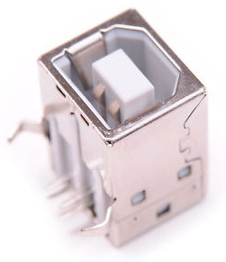

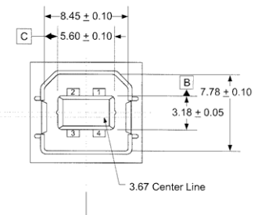

### USB 3.0

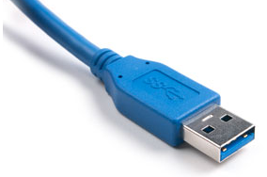**A plug**

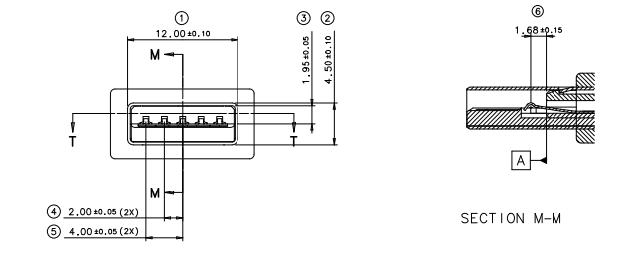

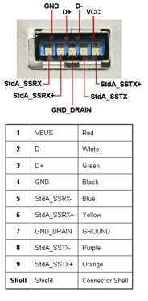

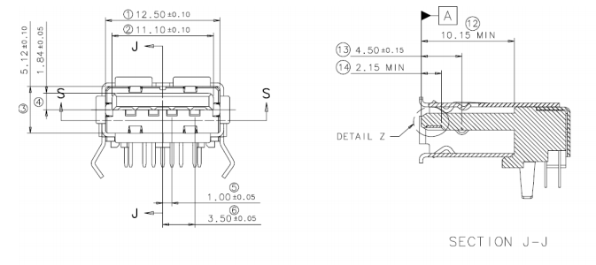**A receptacle**

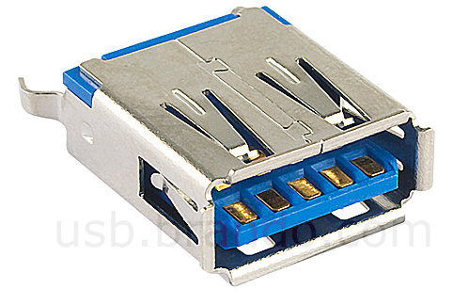

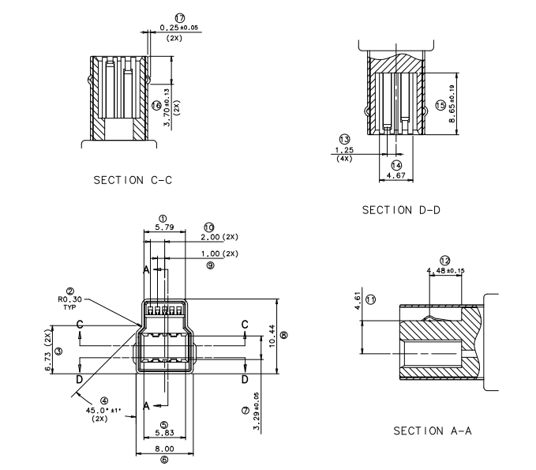**B plug**

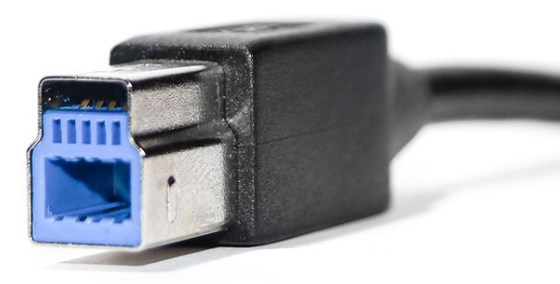

**B receptacle**

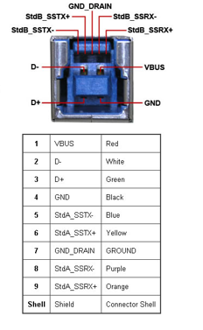

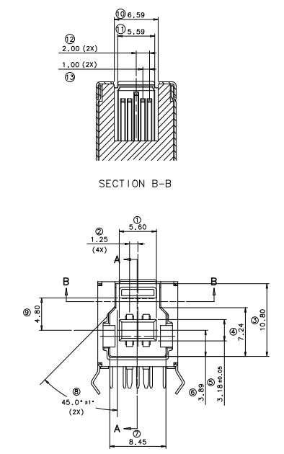

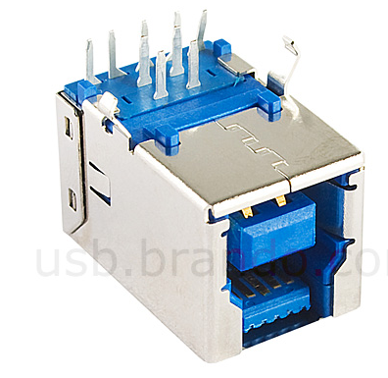

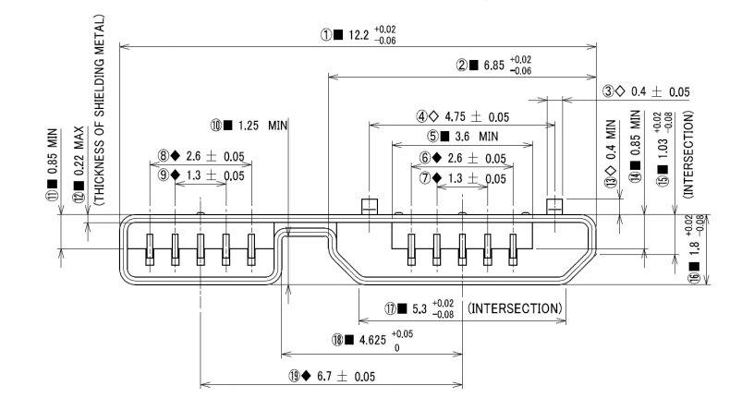**Micro-B plug**

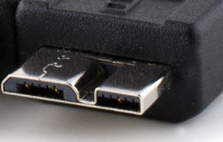

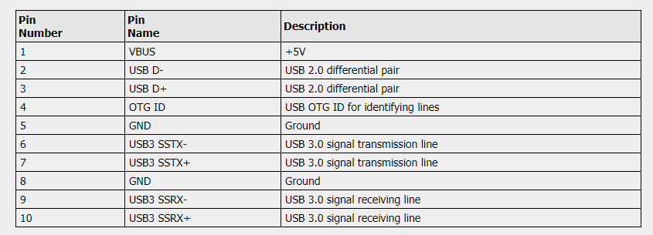

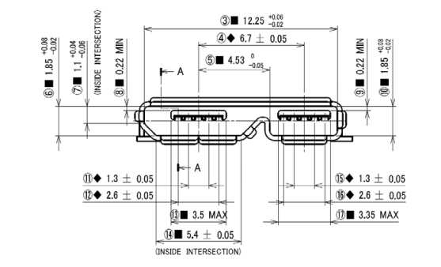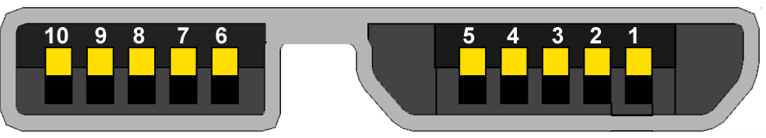**Micro-B receptacle**

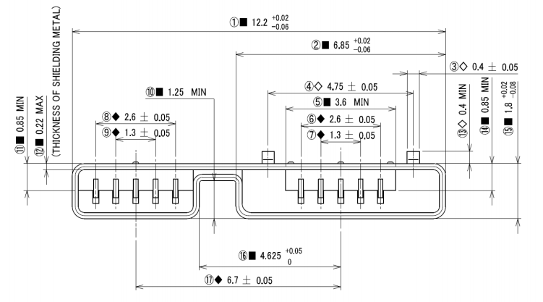**Micro-A plug**

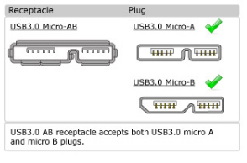

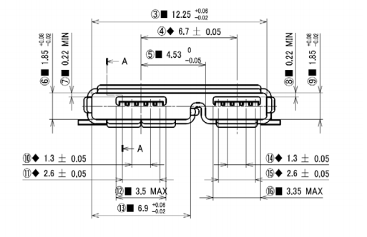**Micro-A receptacle**

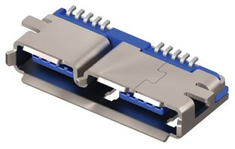

**USB 3.1 (micro USB C plug) USB 3.1 (micro USB C port)**



 