Document elaborat per Alfonso Méndez, Tècnic de Laboratori
Soldadura de componentes electrónicos
Laboratori d’Instrumentació i Bioenginyeria
Departament d’Enginyeria Electrònica

Universitat Politècnica de Catalunya

Soldadura de componentes electrónicos

Descripción
La soldadura es un proceso mediante el que se unen diferentes elementos metálicos, aplicando calor con un soldador y usando como unión una aleación metálica especial. El resultado es una unión metálica que es mecánicamente fuerte y buena conductora de la electricidad.
Llamamos estaño a la aleación que utilizamos para unir los metales. Esta aleación consiste en distintos porcentajes de dos o más metales. La aleación es usualmente de estaño y plomo, sin embargo, la implantación de la directiva RoHs europea en Julio de 2006 limita el uso de sustancias peligrosas en los equipos electrónicos y eléctricos que vayan a ser comercializados. El plomo es una de las sustancias prohibidas.
Cada aleación tiene unas características únicas: punto de fusión, dureza, propiedades de la transición líquido-sólido y puede ser eutéctica o no.
Una aleación eutéctica tiene un punto de fusión de margen muy estrecho y no tiene una etapa intermedia "plástica" Una aleación no-eutéctica tiene un punto de fusión con un rango de temperatura mayor donde tiene un comportamiento plástico.
Por ejemplo, el plomo tiene una temperatura de fusión de 327 ⁰C y el estaño de 232 ⁰C. Una aleación de 63 % de estaño con 37 % de plomo forma una unión eutéctica cuyo punto de fusión es de 183 ⁰C

Consideraciones sobre la soldadura en el diseño de PCBs
PADs Trough hole
Use PADs redondos siempre que sea posible, los PADs ovalados son aceptables pero los rectangulares no, ya que las fuerzas de cohesión que se producen en la soldadura tienden a crear una esfera.
La corona de cobre en un pad redondo debe ser al menos de 0,5 mm en todas direcciones. Esta medida garantiza la fuerza suficiente de adhesión.
Aisle los planos de masa de los pads mediante formas de aislamiento térmico "thermal breaks" para poder transferir el calor de una manera concentrada en el pad.
El diámetro externo de un pad circular debe ser 3 veces el diámetro de la pata del componente. Las pata de un componente stándar tiene unos 0,6 mm de diámetro.

PADs SMD
La zona de contacto entre el pad y el terminal del componente SMD a soldar debe ser lo mayor posible.
El pad SMD debe presentar al aire una superficie al menos igual a la superficie de contacto entre el terminal del componente y el pad, de esta froma se facilita el soldado manual.

FLUX
El flux es un líquido que se aplica a las uniones metálicas que van a ser soldadas para eliminar la oxidación. Presenta las siguientes propiedades:
Es un agente de limpieza medio contra materiales extraños como el polvo.
Disminuye la fuerza de cohesión de la soldadura fundida lo cual ayuda a la humectación.
Proteje de la reoxidación a las superficies metálicas y elimina la suciedad creada durante el calentado.
Aumenta la velocidad de soldado.

Tipos de Flux
De los varios tipos de Flux que hay en el mercado, por temas de respeto al mediambiente se suelen usar los "No clean". Dejan muy pocos residuos sobre los PCBs, son químicamente inertes y buenos aislantes eléctricos. En la mayoría de casos, con este flux no es necesario limpiar el PCB después de soldar
En el Laboratorio tenemos los siguientes tipos de Flux:
Tecsol - Flux "Rosin based" Se limpia con el spray RS Flux-Off Rosin de Chemtronics. El acohol también da buenos resultados.
Future 315 - Flux No clean low residue. Se limpia con el spray RS Flux-Off No clean Plus de Chemtronics.
Flux JBC FM 9600 Flux basado en alcohol. Se limpia con alcohol o con el spray RS Cleaning Fluid ref. 513-679
Flux JBC FL 9582 Flux basado en agua. Producto respetuoso con el medio ambiente. Se limpia con agua o con el spray RS Flux-Off water soluble de Chemtronics..

Estaño
El hilo de estaño usado para soldar suele llevar varias capas de flux incorporado.
En el Laboratorio se suelen encontrar los siguientes tipos de estaño:
- Radiel Sn60PbCu2 de 0,5 mm de diámetro
60 % Sn - 38 % Pb - 2 % Cu, 1 núcleo de Flux de resina CMAB, t fusión: 190ºC
- Radiel Sn62PbAg2 de 0,5 mm de diámetro
60 % Sn - 38 % Pb - 2 % Ag, 3 núcleos de Flux de resina CMAa, t fusión: 190ºC
- Radiel Sn60Pb40 de 0,35 mm de diámetro
- Brofil 60/40 d 1 mm de diámetro

Proceso de soldadura práctico

Componentes "through hole"

Inserción componentes
- Introducir los componentes y doblar las patas un poco (30-45 º) Cortar las patas y dejar unos 2 mm.
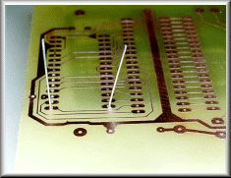
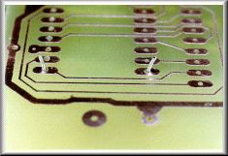

Preparación soldador
- Encender el soldador y esperar que la punta alcance la temperatura de trabajo. La temperatura óptima para la mayoría de trabajos es de 300 ·C
- Humedecer un poco la esponja del soporte con agua destilada.
- Limpiar la punta del soldador en la esponja. Estañar completamente la punta y comprobar que todas las zonas de la punta admiten estaño. Si hubiera zonas que no cogen estaño, significaría que esa zona está oxidada, limpiar enérgicamente con un cepillo de puas de acero y volver a estañar hasta que toda la punta admita estaño.
- Sacudir al aire, con cuidado, para eliminar el exceso de estaño.

Soldadura
- Seleccionar el estaño de 1 mm de diámetro y un soldador de 30 - 40 W
- Poner en contacto los dos metales a soldar (pad y pata) con la punta del soldador.
- Esperar un instante (1 - 2 s) hasta que la temperatura de ambos metales sobrepase la temperatura de fusión del estaño (190 ºC) El estaño no se desplazará hasta una parte metálica que esté por debajo de 190 ºC (ésta es la causa de las soldaduras frías)
- Aplicar el estaño sobre los metales, ¡no en la punta del soldador! El estaño irá cubriendo los metales.
- Cuando la cantidad de estaño sea suficiente, retirar el estaño y el soldador simultáneamente tratando de no mover las partes de la soldadura y dejar enfriar de una manera natural (unos 2 s)
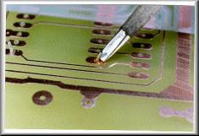
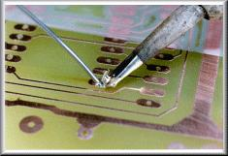
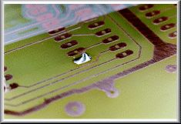
Este proceso debería durar menos de 5 s en total. Si tardara más, la punta o el soldador podrían ser pequeños para la soldadura a realizar o la técnica es incorrecta.

< 2 s ≈ 1 s
Fin de la soldadura
- Estañar abundantemente la punta del soldador, colocar el soldador sobre su soporte y apagar la estación de soldadura.

Componentes pasivos SMD

Preparación soldador
- Encender el soldador y esperar que la punta alcance la temperatura de trabajo. La temperatura óptima para la mayoría de trabajos es de 300 ·C
- Humedecer un poco la esponja del soporte con agua destilada.
- Limpiar la punta del soldador en la esponja. Estañar completamente la punta y comprobar que todas las zonas de la punta admiten estaño. Si hubiera zonas que no cogen estaño, significaría que esa zona está oxidada, limpiar enérgicamente con un cepillo de puas de acero y volver a estañar hasta que toda la punta admita estaño.
- Sacudir al aire, con cuidado, para eliminar el exceso de estaño.

Soldadura
Método 1
- Seleccionar el estaño de 0,5 mm de diámetro y un soldador de 5 - 20 W
- Aplicar una pequeña cantidad de estaño al pad SMD.
- Limpiar bien la punta del soldador, no debe haber estaño.
- Poner flux sobre el pad y posicionar el componente con ayuda de unas pinzas, calentar el estaño que hay en el pad y retirar (< 1 s)
- Aplicar el estaño al otro pad de la manera clásica.
- Si la primera soldadura no hubiera quedado bien, limpiar la punta del soldador para que no haya nada de estaño, aplicar flux sobre la soldadura y refundir el estaño (< 1 s) el exceso de estaño debería marcharse a la punta del soldador.
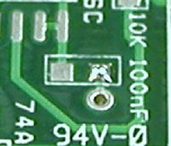
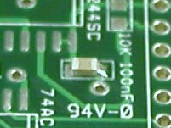
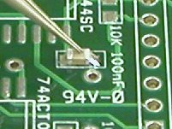

Método 2
- Seleccionar el estaño de 0,5 mm de diámetro y un soldador de 5 - 20 W
- Limpiar bien la punta del soldador y aplicar una pequeña cantidad de estaño sobre la misma.
- Poner flux sobre el pad, posicionar el componente con ayuda de unas pinzas y sujetarlo.
- Aplicar la punta del soldador sobre el pad, el estaño de la punta debería desplazarse hacía el pad.
- Aplicar el estaño al otro pad de la manera clásica.
- Si la primera soldadura no hubiera quedado bien, limpiar la punta del soldador para que no haya nada de estaño, aplicar flux sobre la soldadura y refundir el estaño (< 1 s) el exceso de estaño debería marcharse a la punta del soldador.

Circuitos integrados SMD

Estaciones soldadura

Estación JBC AM 6800 (enlace)
Compuesta de:
Soldador tipo lápiz JBC 2245 50 W (90⁰C - 450⁰C)
Desoldador JBC DR 5650 75 W (90⁰C - 450⁰C)
Soplador de aire caliente JBC JT 7700 1000 W
Pick & place JBC MP2260

Estación JBC AD 4300
Compuesta de:

Lápiz 2210/225
Pinzas PA 1200
- Soldering Iron and tip
- Wattage - 15 watts can be used for very small components and pads. 30 - 50 watts for larger components. Controlled heat irons are the best, but good results can be obtained from the inexpensive fixed temperature irons that have the proper tip wattage.
- Larger irons and "guns" should not be used except to solder very large components. Do not use these high power instruments on electronic assemblies or printed circuit boards.
- Soldering Iron Tip - The tip should be small enough so that the joint being soldered can be easily seen, but large enough to quickly transfer the heat required to raise the joint temperature to the solder melting point. The author prefers a chisel (spade) tip that is between 0.05" and 0.08" across the spade for general purpose soldering. Smaller tips are required for small pads and surface mount components. The larger tip provides more heat which is required for desoldering using desoldering braid or solder pump.
- Solder
- Do not use acid core solder, corrosive fluxes, or conductive fluxes on electronic equipment. Use mild fluxes such as contained in rosin core solder or rosin flux.
- Use the correct alloy. SN63 is excellent for small, heat sensitive components and printed circuit board pads. SN60 is an inexpensive excellent all-around solder. Both are available with flux cores (usually rosin). Some fluxes are sticky once activated by heat and thus should be cleaned off the board once soldering is completed since they will accumulate dust/contaminants that may cause an unwanted short or low resistance path at a later time.
- Use the correct diameter of solder especially for small component attach points. (Author's opinions below)
- 0.020" dia. (25 gauge/.05 cm) rosin core or smaller - Very small. Excellent for soldering very small printed circuit (PCB) board pads and hand soldering surface mount components. Too small for a general purpose bench solder. It can take excessive heating time to apply sufficient solder to larger joints. The author has a small roll of 0.15 dia. solder on his bench but uses it very infrequently.
- 0.031" dia.(21 gauge/.079 cm) rosin core - An excellent all around solder for printed circuit boards and general kit building/electronic repair. Inexperienced users may have some difficulty from forming solder bridges between pads on junctions spaced 0.1" or less such as PCB integrated circuit pads. This is the author's favorite size and is plentiful in his shop.
- 0.040" dia. (19 gauge/0.1 cm) rosin core - Good for larger connections like tinning or connecting 14 gauge or larger wires to terminal strips, connecting multiwires. Not good for PCB soldering because excessive solder can be easily applied to pads increasing potential for undesired solder bridges between points. The author has it available on his bench, but hardly ever uses it.
- Larger diameter solder should be reserved for soldering large items like very large stranded wires, soldering large items to aluminum chassis, etc. The largest the author has is 0.047" dia. and he has never needed anything larger for electronics projects. It is very seldom used.
- Hand Tools and supplies
- Side-cutters or "dikes" - Miniature side-cutters with spring to hold the jaws open are ideal. The author prefers 5 - 51/2-inch for small wires and 6-inch or greater for the larger wires. Most of the small cutters are for soft wire and can be damaged cutting hard wires such as aluminum, iron or steel.
- Medium long-nose pliers - The same length as the side-cutters work fine. The pliers should have round points so that component leads can be formed around them when necessary. A pliar with 4" or longer nose is very useful for many hard-to-reach applications.

- Desoldering equipment - A roll of desoldering braid and a vacuum desoldering tool will cover most desoldering requirements. The desoldering pump is best for removing large amounts of solder, and the braid for removing small amounts and cleaning up solder holes in PCB's. The author often uses a pin vise with a #65 drill bit to clean solder pad holes.
- Sponge - A damp sponge is very useful to keep the soldering tip free from excess solder and contamination. Special solder tip cleaning pastes are also available and do a good job of removing oxidized material from soldering iron tips.
- Wire brush - A wire brush is useful to remove oxidation that may coat the soldering tip after prolonged service. Be sure and tin the tip immediately after brushing. Steel wool can also be used to clean the tip as well as tarnished/contaminated component leads and surfaces to be soldered.

2. PREPARE THE SURFACES TO BE SOLDERED
- PCB's and surfaces. A thin film of oxide forms on bare copper that will be detected as surface dullness and darkening of the copper. Thus, if bare copper is to be soldered, it is very important to clean it with fine (0000) steel wool or equivalent. The surface should be bright and shiny.

- Tinned surfaces do not normally need to be cleaned with steel wool, but all contamination like dirt, oil, etc., must be removed. Rubbing alcohol or detergent and water (if no components have been mounted) are good liquids to use.

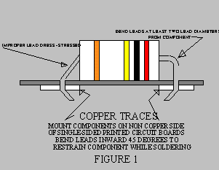
- Use steel wool or fine sandpaper to clean leads of components stored for long periods. Some components, especially old resistors and capacitors, will have tinned leads that look dull rather than shiny. It is a good idea to use steel wool to clean them before soldering.

3. MOUNTING THE COMPONENTS ON A PCB
- Mount components on non-foil side with leads protruding through the board to the copper side.
- Place components against the board.
- Extend leads from component so that they are stress relieved (see Figure 1). Bends should be at least two lead diameters from the component. Minimum inside radius of the bend should be equal to a lead diameter. Part identification should be visible with the part in place.
4. PREPARING THE SOLDERING IRON TIP BEFORE SOLDERING
- The solder tip must be applied to the joint at such an angle that the point of contact can be observed during the soldering process. This is generally at about a 45^{O} angle.
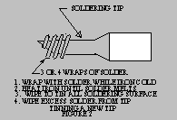
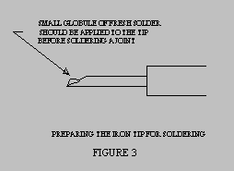
- The soldering tip must be clean and freshly tinned before soldering. It is extremely important that a new, never been heated tip be tinned immediately upon it reaching the temperature that melts solder. Tinning is accomplished by applying fresh solder and flux to the tip and allowing all soldering surfaces to become coated with solder. If tinning is not done, then the tip will become oxidized and it will be impossible to solder a good joint. This oxidization is often difficult, if not impossible to remove. Copper tips (copper color) can be filed, but do not file a tip that has been plated (silver color). The tip should be allowed to cool and then brushed vigorously with a wire brush until the dark black/brown oxidized material is removed. Sandpaper or a fine file may be used to assist in this process. Then reheat and tin as stated above. Plated tips should not be filed or sanded.
- If the tip has already been tinned and has no oxidation, then clean the tip by wiping on a damp sponge or other suitable material before each connection is made.
- Place a very small globule of fresh flux-core solder on the tip surface that will be used as the point of contact with the parts to be soldered.
5. APPLY THE CORRECT AMOUNT OF HEAT AND SOLDER
- The soldering iron tip should be applied firmly to the metal part having the greatest mass while also touching the part to be soldered to it.
- Apply heat until both the parts to be joined are sufficiently hot to melt the solder.
- Quickly apply solder adjacent to the tip, but not on the tip (Refer to Figure 5). The solder should flow quickly around the components. Withdraw the tip as soon as the joint is complete to avoid overheating the molten solder. The soldering process should be completed within 2 seconds. If it takes up to 5 seconds then the tip is too small, the iron too small, or the technique incorrect. The soldering tip should be at a temperature of about 650^{O} F (343 ^{O}C ).
- The surface temperature of both metals being soldered must be above the solder melting point to expedite efficient wetting. Solder should not be permitted to flow onto a surface cooler than the solder temperature; this will cause "cold" joints.
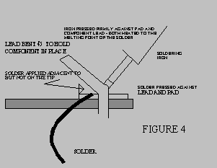
Properly applied solder will melt and flow smoothly around the surfaces being soldered producing a smooth, shiny surface feathering out to a smooth thin edge.
- A rounded, lumpy, dull, irregular, or granular appearance indicates improper solder application.
6. DO NOT ALLOW JOINT TO MOVE
- Once the joint is soldered, it is imperative that none of the soldered parts be allowed to move until the solder solidifies.
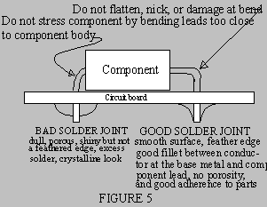
- Premature movement will cause the solder to fracture at the component to solder interface, thereby producing a "fractured" joint. These joints can be expected to fail later while in service.
7. FINISHING THE SOLDERED JOINT
- Cut off excess leads (Refer to Figure 6). Do not clip into the feathered solder edge. Leave a slight headroom so that the solder is not separated from the lead by the shock forces imparted during cutting.
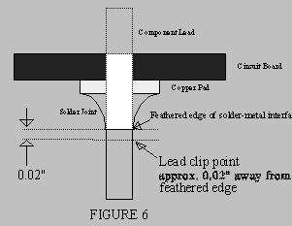
- Clean soldered board board with flux remover or alcohol after all joints have been soldered and leads clipped. This may not be necessary with some fluxes.
8. THINGS THAT MAKE A BAD SOLDER JOINT
- Excessive solder applied to joints pose the possibility of unwanted solder bridges between adjacent joints.
- Applying too little solder allows low joint strength. Solder should completely fill printed circuit board pads all around the component lead being soldered.
- Moving the joint before the solder solidifies will create a "fractured" joint. The solder to metal bond is fractured just before solidification of the solder. This failure may not be detected for years. This joint often looks non shiney and grainy, especially at the interface.
- Applying too little heat will cause a "cold" solder joint. This joint may adhere for a while, but can be expected to fail in time. This joint likely does not have feathered edges where it interfaces with the pad and with the lead. It is generally has a solder globule appearance rather than with feathered edges. It may be shiney.
- Applying too much heat to the tip will accelerate oxidation of the tip and cause the solder to "roll" off it rather than wet it. A non wetted/tinned soldering tip will cause excessive heat application time to circuit board pad and component. Pads can even unadhere to the circuit board if too much heat is applied.
- Soldering a contaminated board or one with excessive oxide will produce a non-functioning joint. The solder will tend to roll off the joint rather than bond.
- Soldering with no flux or too little flux will produce a non acceptable solder joint Solder will often ball up and be globular in appearance.
- Soldering electronic parts with acid core solder, corrosive flux, or conductive flux.
DESOLDERING
1. Many times, soldered components or wires must be removed.
2. There are at least two good ways to desolder components. One is by using a desoldering pump and the other is by using a desoldering braid.
3. The desoldering tool is applied to a joint that has been heated to the solder's melting point. A plunger is activated which "sucks" the solder into the tool's reservoir. If done properly, this method can remove solder to the point that the component leads can be lifted away from the metal to which they were joined.
4. If the joint does not have too much solder, then desoldering braid can be used to remove the solder. This braid consists of copper braid impregnated with non-corrosive flux. The braid is laid on top of the solder joint to be desoldered and the hot soldering tip applied to the braid. Solder will flow towards the heat of the tip and away from the joint.
5. A good method of desoldering involves both of the above methods. Most of the solder can be removed with the desoldering pump and any remaining with desoldering braid.
6. Desoldering irons are also available. These irons have vacuum devices attached to them. The iron melts the solder and then the vacuum is energized which sucks the molten solder into a reservoir for disposal.

Enlaces:

http://www.epemag.wimborne.co.uk/solderfaq.htm
http://www.planetaelectronico.com/cursillo/tema1/tema1.4.html
http://www.technick.net/public/code/cp_dpage.php?aiocp_dp=how_to_solder
http://www.infidigm.net/articles/solder/#pinbypin

